Editorial

Inkblot districts are visible proof of Albany’s gerrymandering
Senate GOP flouts Constitution to keep power

Updated: Monday, January 30, 2012, 4:10 AM

Do not mistake the nearby shapes for Rorschach inkblots.
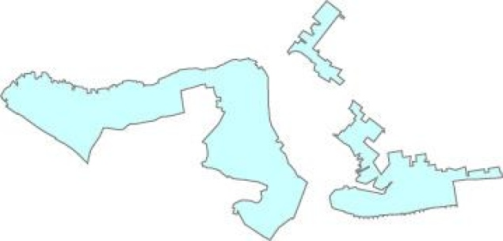

The proposed District 23, a blatant product of Republican gerrymandering.
Read more: http://www.nydailynews.com/opinion/inkblot-districts-visible-proof-albany-gerrymandering-article-1.1013204#ixzz1kwgCzJbg
They are visible proof of how flagrantly state Senate Republicans distorted the process of redrawing election districts.

The weird outlines also document why Gov. Cuomo must veto the maps.

The Legislature sets new districts every 10 years, after each census. The Assembly, dominated by Democrats, sets boundaries that give decided advantages to Democrats. The Senate’s GOP majority does the same for Republicans. But this time, Senate Majority Leader Dean Skelos has taken gerrymandering to repugnant lengths in a desperate bid to maintain his razor-thin control.

The state Constitution requires that districts “shall contain as nearly as may be an equal number of inhabitants.”

They should also be “compact” and consist of “contiguous territory.”

These shapes, of proposed Districts 19 and 23, make a mockery of those principles.

The proposed District 19 (right) — represented by Senate Democratic Leader John Sampson — covers eastern Brooklyn bordering Jamaica Bay. So what the heck is that thing dangling off like a chubby dog on a leash?

It happens to include the home of City Councilman Lew Fidler, a Democrat who is favored against a Republican in a race for a vacant Senate seat.

To neuter Fidler, the Republicans made his neighborhood an appendage to Sampson’s district, forcing him to compete against a fellow Democrat while giving the GOP a better shot at a neighboring seat.

Equally unjustifiable is the shape of District 23 (at top). The area includes northern Staten Island, then runs down the center median of the

Verrazano Bridge and along slim strips of uninhabited Brooklyn shoreline to connect with a small piece of Sunset Park to the west and a part of Gravesend, Coney Island, Brighton Beach and a sliver of Sheepshead Bay to the east.

What’s the GOP’s point?
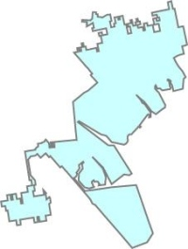

District 19 looks like a chubby dog on a leash.
Read more: http://www.nydailynews.com/opinion/inkblot-districts-visible-proof-albany-gerrymandering-article-1.1013204#ixzz1kwfoayrh

The district’s Staten Island portion is the heavily Democratic stronghold of Democrat Diane Savino. Republicans have no chance of unseating her, so adding far-flung Brooklyn Democrats to Savino’s district does no harm to the GOP.

Meanwhile, attaching those Dem voters to Staten Island will be a boon to Bay Ridge Republican Sen. Marty Golden, who’s been given his own bizarrely shaped district — one that packs in as many Republicans as possible.

The evidence could not be clearer.

Skelos and his Republicans drew odd-looking districts to maintain power.

That’s the very definition of gerrymandering that Cuomo rightly declared would not be allowed on his watch.

Veto away, governor.

